SQL Table
Last update on April 14 2018 06:14:58 (UTC/GMT +8 hours)

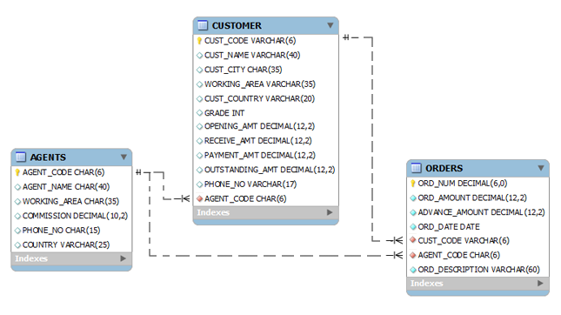
Here is the command to create the table agents:
CREATE TABLE "AGENTS"
(
"AGENT_CODE" CHAR(6) NOT NULL PRIMARY KEY,
"AGENT_NAME" CHAR(40),
"WORKING_AREA" CHAR(35),
"COMMISSION" NUMBER(10,2),
"PHONE_NO" CHAR(15),
"COUNTRY" VARCHAR2(25)
);
Copy
Now insert records into the table agents :
INSERT INTO AGENTS VALUES ('A007', 'Ramasundar', 'Bangalore', '0.15', '077-25814763', '');
INSERT INTO AGENTS VALUES ('A003', 'Alex ', 'London', '0.13', '075-12458969', '');
INSERT INTO AGENTS VALUES ('A008', 'Alford', 'New York', '0.12', '044-25874365', '');
INSERT INTO AGENTS VALUES ('A011', 'Ravi Kumar', 'Bangalore', '0.15', '077-45625874', '');
INSERT INTO AGENTS VALUES ('A010', 'Santakumar', 'Chennai', '0.14', '007-22388644', '');
INSERT INTO AGENTS VALUES ('A012', 'Lucida', 'San Jose', '0.12', '044-52981425', '');
INSERT INTO AGENTS VALUES ('A005', 'Anderson', 'Brisban', '0.13', '045-21447739', '');
INSERT INTO AGENTS VALUES ('A001', 'Subbarao', 'Bangalore', '0.14', '077-12346674', '');
INSERT INTO AGENTS VALUES ('A002', 'Mukesh', 'Mumbai', '0.11', '029-12358964', '');
INSERT INTO AGENTS VALUES ('A006', 'McDen', 'London', '0.15', '078-22255588', '');
INSERT INTO AGENTS VALUES ('A004', 'Ivan', 'Torento', '0.15', '008-22544166', '');
INSERT INTO AGENTS VALUES ('A009', 'Benjamin', 'Hampshair', '0.11', '008-22536178', '');
Copy
Here is the command to create the table customer :
CREATE TABLE "CUSTOMER"
( "CUST_CODE" VARCHAR2(6) NOT NULL PRIMARY KEY,
"CUST_NAME" VARCHAR2(40) NOT NULL,
"CUST_CITY" CHAR(35),
"WORKING_AREA" VARCHAR2(35) NOT NULL,
"CUST_COUNTRY" VARCHAR2(20) NOT NULL,
"GRADE" NUMBER,
"OPENING_AMT" NUMBER(12,2) NOT NULL,
"RECEIVE_AMT" NUMBER(12,2) NOT NULL,
"PAYMENT_AMT" NUMBER(12,2) NOT NULL,
"OUTSTANDING_AMT" NUMBER(12,2) NOT NULL,
"PHONE_NO" VARCHAR2(17) NOT NULL,
"AGENT_CODE" CHAR(6) NOT NULL REFERENCES AGENTS
);
Copy
Now insert records into the table customer :
INSERT INTO CUSTOMER VALUES ('C00013', 'Holmes', 'London', 'London', 'UK', '2', '6000.00', '5000.00', '7000.00', '4000.00', 'BBBBBBB', 'A003');
INSERT INTO CUSTOMER VALUES ('C00001', 'Micheal', 'New York', 'New York', 'USA', '2', '3000.00', '5000.00', '2000.00', '6000.00', 'CCCCCCC', 'A008');
INSERT INTO CUSTOMER VALUES ('C00020', 'Albert', 'New York', 'New York', 'USA', '3', '5000.00', '7000.00', '6000.00', '6000.00', 'BBBBSBB', 'A008');
INSERT INTO CUSTOMER VALUES ('C00025', 'Ravindran', 'Bangalore', 'Bangalore', 'India', '2', '5000.00', '7000.00', '4000.00', '8000.00', 'AVAVAVA', 'A011');
INSERT INTO CUSTOMER VALUES ('C00024', 'Cook', 'London', 'London', 'UK', '2', '4000.00', '9000.00', '7000.00', '6000.00', 'FSDDSDF', 'A006');
INSERT INTO CUSTOMER VALUES ('C00015', 'Stuart', 'London', 'London', 'UK', '1', '6000.00', '8000.00', '3000.00', '11000.00', 'GFSGERS', 'A003');
INSERT INTO CUSTOMER VALUES ('C00002', 'Bolt', 'New York', 'New York', 'USA', '3', '5000.00', '7000.00', '9000.00', '3000.00', 'DDNRDRH', 'A008');
INSERT INTO CUSTOMER VALUES ('C00018', 'Fleming', 'Brisban', 'Brisban', 'Australia', '2', '7000.00', '7000.00', '9000.00', '5000.00', 'NHBGVFC', 'A005');
INSERT INTO CUSTOMER VALUES ('C00021', 'Jacks', 'Brisban', 'Brisban', 'Australia', '1', '7000.00', '7000.00', '7000.00', '7000.00', 'WERTGDF', 'A005');
INSERT INTO CUSTOMER VALUES ('C00019', 'Yearannaidu', 'Chennai', 'Chennai', 'India', '1', '8000.00', '7000.00', '7000.00', '8000.00', 'ZZZZBFV', 'A010');
INSERT INTO CUSTOMER VALUES ('C00005', 'Sasikant', 'Mumbai', 'Mumbai', 'India', '1', '7000.00', '11000.00', '7000.00', '11000.00', '147-25896312', 'A002');
INSERT INTO CUSTOMER VALUES ('C00007', 'Ramanathan', 'Chennai', 'Chennai', 'India', '1', '7000.00', '11000.00', '9000.00', '9000.00', 'GHRDWSD', 'A010');
INSERT INTO CUSTOMER VALUES ('C00022', 'Avinash', 'Mumbai', 'Mumbai', 'India', '2', '7000.00', '11000.00', '9000.00', '9000.00', '113-12345678','A002');
INSERT INTO CUSTOMER VALUES ('C00004', 'Winston', 'Brisban', 'Brisban', 'Australia', '1', '5000.00', '8000.00', '7000.00', '6000.00', 'AAAAAAA', 'A005');
INSERT INTO CUSTOMER VALUES ('C00023', 'Karl', 'London', 'London', 'UK', '0', '4000.00', '6000.00', '7000.00', '3000.00', 'AAAABAA', 'A006');
INSERT INTO CUSTOMER VALUES ('C00006', 'Shilton', 'Torento', 'Torento', 'Canada', '1', '10000.00', '7000.00', '6000.00', '11000.00', 'DDDDDDD', 'A004');
INSERT INTO CUSTOMER VALUES ('C00010', 'Charles', 'Hampshair', 'Hampshair', 'UK', '3', '6000.00', '4000.00', '5000.00', '5000.00', 'MMMMMMM', 'A009');
INSERT INTO CUSTOMER VALUES ('C00017', 'Srinivas', 'Bangalore', 'Bangalore', 'India', '2', '8000.00', '4000.00', '3000.00', '9000.00', 'AAAAAAB', 'A007');
INSERT INTO CUSTOMER VALUES ('C00012', 'Steven', 'San Jose', 'San Jose', 'USA', '1', '5000.00', '7000.00', '9000.00', '3000.00', 'KRFYGJK', 'A012');
INSERT INTO CUSTOMER VALUES ('C00008', 'Karolina', 'Torento', 'Torento', 'Canada', '1', '7000.00', '7000.00', '9000.00', '5000.00', 'HJKORED', 'A004');
INSERT INTO CUSTOMER VALUES ('C00003', 'Martin', 'Torento', 'Torento', 'Canada', '2', '8000.00', '7000.00', '7000.00', '8000.00', 'MJYURFD', 'A004');
INSERT INTO CUSTOMER VALUES ('C00009', 'Ramesh', 'Mumbai', 'Mumbai', 'India', '3', '8000.00', '7000.00', '3000.00', '12000.00', 'Phone No', 'A002');
INSERT INTO CUSTOMER VALUES ('C00014', 'Rangarappa', 'Bangalore', 'Bangalore', 'India', '2', '8000.00', '11000.00', '7000.00', '12000.00', 'AAAATGF', 'A001');
INSERT INTO CUSTOMER VALUES ('C00016', 'Venkatpati', 'Bangalore', 'Bangalore', 'India', '2', '8000.00', '11000.00', '7000.00', '12000.00', 'JRTVFDD', 'A007');
INSERT INTO CUSTOMER VALUES ('C00011', 'Sundariya', 'Chennai', 'Chennai', 'India', '3', '7000.00', '11000.00', '7000.00', '11000.00', 'PPHGRTS', 'A010');
Copy
Here is the command to create the table orders :
CREATE TABLE "ORDERS"
(
"ORD_NUM" NUMBER(6,0) NOT NULL PRIMARY KEY,
"ORD_AMOUNT" NUMBER(12,2) NOT NULL,
"ADVANCE_AMOUNT" NUMBER(12,2) NOT NULL,
"ORD_DATE" DATE NOT NULL,
"CUST_CODE" VARCHAR2(6) NOT NULL REFERENCES CUSTOMER,
"AGENT_CODE" CHAR(6) NOT NULL REFERENCES AGENTS,
"ORD_DESCRIPTION" VARCHAR2(60) NOT NULL
);
Copy
Now insert records into the table orders :
INSERT INTO ORDERS VALUES('200100', '1000.00', '600.00', '08/01/2008', 'C00013', 'A003', 'SOD');
INSERT INTO ORDERS VALUES('200110', '3000.00', '500.00', '04/15/2008', 'C00019', 'A010', 'SOD');
INSERT INTO ORDERS VALUES('200107', '4500.00', '900.00', '08/30/2008', 'C00007', 'A010', 'SOD');
INSERT INTO ORDERS VALUES('200112', '2000.00', '400.00', '05/30/2008', 'C00016', 'A007', 'SOD');
INSERT INTO ORDERS VALUES('200113', '4000.00', '600.00', '06/10/2008', 'C00022', 'A002', 'SOD');
INSERT INTO ORDERS VALUES('200102', '2000.00', '300.00', '05/25/2008', 'C00012', 'A012', 'SOD');
INSERT INTO ORDERS VALUES('200114', '3500.00', '2000.00', '08/15/2008', 'C00002', 'A008', 'SOD');
INSERT INTO ORDERS VALUES('200122', '2500.00', '400.00', '09/16/2008', 'C00003', 'A004', 'SOD');
INSERT INTO ORDERS VALUES('200118', '500.00', '100.00', '07/20/2008', 'C00023', 'A006', 'SOD');
INSERT INTO ORDERS VALUES('200119', '4000.00', '700.00', '09/16/2008', 'C00007', 'A010', 'SOD');
INSERT INTO ORDERS VALUES('200121', '1500.00', '600.00', '09/23/2008', 'C00008', 'A004', 'SOD');
INSERT INTO ORDERS VALUES('200130', '2500.00', '400.00', '07/30/2008', 'C00025', 'A011', 'SOD');
INSERT INTO ORDERS VALUES('200134', '4200.00', '1800.00', '09/25/2008', 'C00004', 'A005', 'SOD');
INSERT INTO ORDERS VALUES('200108', '4000.00', '600.00', '02/15/2008', 'C00008', 'A004', 'SOD');
INSERT INTO ORDERS VALUES('200103', '1500.00', '700.00', '05/15/2008', 'C00021', 'A005', 'SOD');
INSERT INTO ORDERS VALUES('200105', '2500.00', '500.00', '07/18/2008', 'C00025', 'A011', 'SOD');
INSERT INTO ORDERS VALUES('200109', '3500.00', '800.00', '07/30/2008', 'C00011', 'A010', 'SOD');
INSERT INTO ORDERS VALUES('200101', '3000.00', '1000.00', '07/15/2008', 'C00001', 'A008', 'SOD');
INSERT INTO ORDERS VALUES('200111', '1000.00', '300.00', '07/10/2008', 'C00020', 'A008', 'SOD');
INSERT INTO ORDERS VALUES('200104', '1500.00', '500.00', '03/13/2008', 'C00006', 'A004', 'SOD');
INSERT INTO ORDERS VALUES('200106', '2500.00', '700.00', '04/20/2008', 'C00005', 'A002', 'SOD');
INSERT INTO ORDERS VALUES('200125', '2000.00', '600.00', '10/10/2008', 'C00018', 'A005', 'SOD');
INSERT INTO ORDERS VALUES('200117', '800.00', '200.00', '10/20/2008', 'C00014', 'A001', 'SOD');
INSERT INTO ORDERS VALUES('200123', '500.00', '100.00', '09/16/2008', 'C00022', 'A002', 'SOD');
INSERT INTO ORDERS VALUES('200120', '500.00', '100.00', '07/20/2008', 'C00009', 'A002', 'SOD');
INSERT INTO ORDERS VALUES('200116', '500.00', '100.00', '07/13/2008', 'C00010', 'A009', 'SOD');
INSERT INTO ORDERS VALUES('200124', '500.00', '100.00', '06/20/2008', 'C00017', 'A007', 'SOD');
INSERT INTO ORDERS VALUES('200126', '500.00', '100.00', '06/24/2008', 'C00022', 'A002', 'SOD');
INSERT INTO ORDERS VALUES('200129', '2500.00', '500.00', '07/20/2008', 'C00024', 'A006', 'SOD');
INSERT INTO ORDERS VALUES('200127', '2500.00', '400.00', '07/20/2008', 'C00015', 'A003', 'SOD');
INSERT INTO ORDERS VALUES('200128', '3500.00', '1500.00', '07/20/2008', 'C00009', 'A002', 'SOD');
INSERT INTO ORDERS VALUES('200135', '2000.00', '800.00', '09/16/2008', 'C00007', 'A010', 'SOD');
INSERT INTO ORDERS VALUES('200131', '900.00', '150.00', '08/26/2008', 'C00012', 'A012', 'SOD');
INSERT INTO ORDERS VALUES('200133', '1200.00', '400.00', '06/29/2008', 'C00009', 'A002', 'SOD');
Copy
For MySQL, create a database first, select that and then import the given txt file.

Single Row Subqueries
A single row subquery returns zero or one row to the outer SQL statement. You can place a subquery in a WHERE clause, a HAVING clause, or a FROM clause of a SELECT statement.
Contents:
- Single Row SubQueries in WHERE clause
- Using comparison operators in Single Row subqueries
- Subqueries in a HAVING clause
- Subqueries in a FROM clause
- Error in Single Row Subqueries

Single Row Subqueries in WHERE clause
You can place a subquery in the WHERE clause of another query. Let's take an example of a query that contains a subquery placed in it's WHERE clause.
Sample table: agents

SQL Code:
SELECT agent_name, agent_code, phone_no
FROM agents
WHERE agent_code =
(SELECT agent_code
FROM agents
WHERE agent_name = 'Alex');
Copy
Output:
AGENT_NAME AGENT_CODE PHONE_NO
---------------------------------------- ---------- ---------------
Alex A003 075-12458969
The above example retrieves the ageent_name, agent_code, phone_no from the agents table whose agent_name is 'Alex'. Let's break the query in two parts and analyze what's going on.
SQL Code:
SELECT agent_code
FROM agents
WHERE agent_name = 'Alex';
Copy
Output:
AGENT_CODE
----------
A003
The above subquery is executed first and returns the agent_code for the row whose agent_name is 'Alex'. The agent_code for this row is 'A003', which is passed to the where clause of the outer (main) query.
The simplified form of above code is :
SQL Code:
SELECT agent_name, agent_code, phone_no
FROM agents
WHERE agent_code = 'A003';
Copy
Pictorical Presentation:
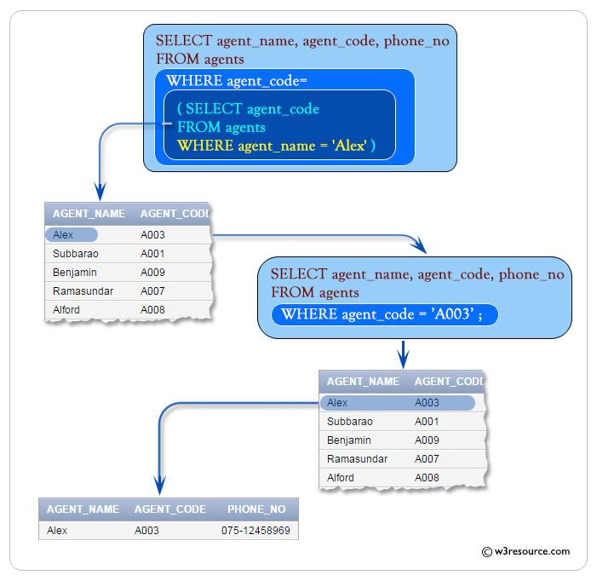

Using comparison operators in Single Row subqueries
The previous example used the equality operator (=) in the WHERE clause. Other comparison operators such as <>, >, <, <= can be used with a single subquery. The following example uses ' <' operator in the outer query WHERE clause. The AVG() function is used in the subquery to get the average order amount, which is passed to the WHERE clause of the outer query. The final result of the entire query is to get the 'ord_num', 'ord_amount', 'ord_date', 'cust_code' and 'agent_code' with following conditions:
Condition in outer query:
the 'ord_amount' of 'orders' table must be greater than the average 'ord_amount' of 'orders' table with following condition an inner join.
Condition in inner query:
'ord_date' of 'orders' table must be '20-APR-08' for calculating the average 'ord_amount'.
Sample table: orders

Here is the complete SQL statement:
SQL Code:
SELECT ord_num,ord_amount,ord_date,cust_code, agent_code
FROM orders
WHERE ord_amount>
(SELECT AVG(ord_amount)
FROM orders
WHERE ord_date='20-APR-08');
Copy
Output:
ORD_NUM ORD_AMOUNT ORD_DATE CUST_CODE AGENT_CODE
--------- ---------- --------- ---------- ----------
200114 3500 15-AUG-08 C00002 A008
200119 4000 16-SEP-08 C00007 A010
200134 4200 25-SEP-08 C00004 A005
200108 4000 15-FEB-08 C00008 A004
200109 3500 30-JUL-08 C00011 A010
200101 3000 15-JUL-08 C00001 A008
200128 3500 20-JUL-08 C00009 A002
200132 4000 15-AUG-08 C00013 A013
200110 3000 15-APR-08 C00019 A010
200107 4500 30-AUG-08 C00007 A010
200113 4000 10-JUN-08 C00022 A002
Let's break the query and analyze what's going on in inner query. Here is the code of inner query :
SQL Code:
SELECT AVG(ord_amount)
FROM orders
WHERE ord_date='20-APR-08';
Copy
Output:
AVG(ORD_AMOUNT)
---------------
2500
The above query returns the average 'ord_amount' 2500, is used in the WHERE clause of the outer query shown earlier.
The simplified form of above code is:
SQL Code:
SELECT ord_num,ord_amount,ord_date,cust_code, agent_code
FROM orders
WHERE ord_amount>2500;
Copy
Pictorical Presentation:
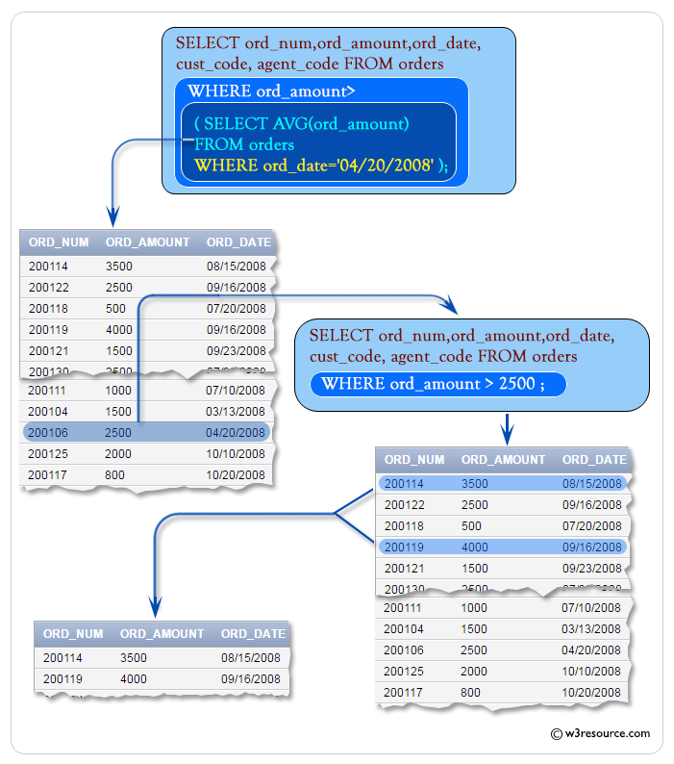

Subqueries in a HAVING clause
HAVING clause is used to filter groups of rows. You may place a subquery in HAVING clause in an outer query. This allows you to filter groups of rows based on the result returned by your subquery. The following example uses a subquery in the HAVING clause of the outer query. This example retrieves 'ord_amount, number of agent_codes and agent_code' from the table orders with following conditions:
- agent_code of orders table must come distinctly.
- an average of ord_amount of each group of agent_code in orders table must be equal to the average ord_amount of orders table.
- agent_code of orders table must be 'A008'.
Sample table: orders

Here is the complete SQL statement:
SQL Code:
SELECT AVG(ord_amount),COUNT(agent_code),agent_code
FROM orders
GROUP BY agent_code
HAVING AVG(ord_amount)=
(SELECT AVG(ord_amount)
FROM orders
WHERE agent_code='A008');
Copy
Output:
AVG(ORD_AMOUNT) COUNT(AGENT_CODE) AGENT_CODE
--------------- ----------------- ----------
2500 2 A011
2500 3 A008
Let's break the code and analyze what's going on in inner query. Here is the code of inner query:
SQL Code:
SELECT AVG(ord_amount)
FROM orders
WHERE agent_code='A008';
Copy
Output:
AVG(ORD_AMOUNT)
---------------
2500
The inner of the above query returns the average 'ord_amount' 2500.
The simplified form of the code is:
SQL Code:
SELECT AVG(ord_amount),COUNT(agent_code),agent_code
FROM orders
GROUP BY agent_code
HAVING AVG(ord_amount)=2500;
Copy
Pictorial Presentation:
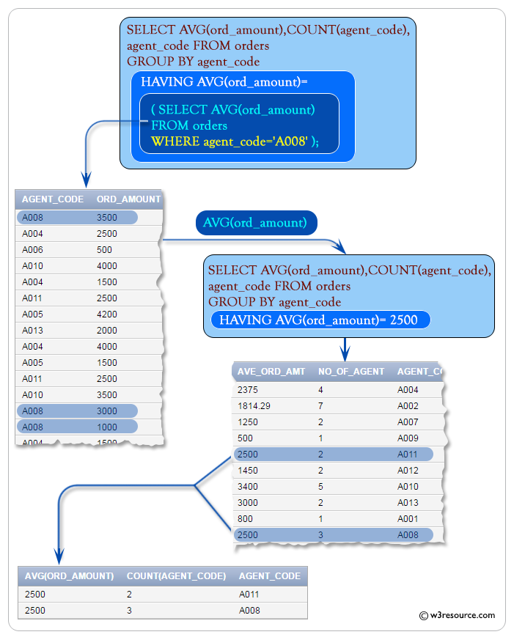

Subqueries in a FROM clause
You may place a subquery in the FROM clause of an outer query. These types of subqueries are also known is inline views because the subquery provides data inline with the FROM clause. The following example retrieves the item_id whose item_id is less than 4.
Sample table: foods

Here is the SQL statement:
SQL Code:
SELECT item_id
FROM
(SELECT item_id
FROM FOODS
WHERE item_id<4)
Copy
Output:
ITEM_ID
------
1
2
3
The subquery returns the rows from the foods table whose item_id is less than 4 to the outer query, which then retrieves and display those item_id values. As far is the FROM clause of the outer query is concerned the output from the subquery is just another source of data.
Pictorical Presentation :
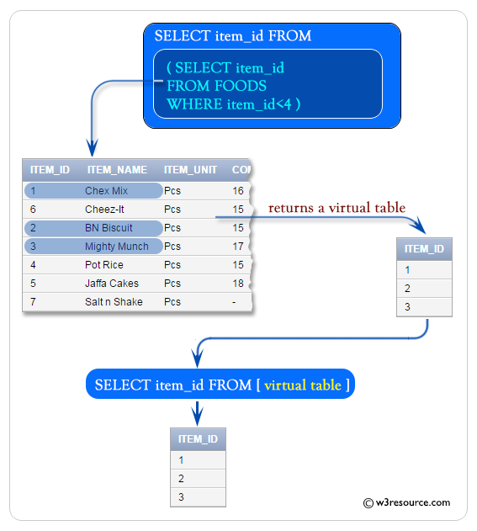

Error in Single Row Subqueries
In this section, we will discuss some errors you might face in a 'single row subquery' operation. In our previous examples, we have seen, a single row subquery always returns a single row and if a subquery returns more than one row then an error occurs. In the following example, the subquery attempts to pass multiple rows to the equality operator (=) in the outer query.
Sample table: foods

SQL Code:
SELECT item_id, item_name
FROM foods
WHERE item_id =
(SELECT item_id
FROM foods
WHERE item_name LIKE '%a%');
Copy
If you run the query in the Oracle Database 10g Express Edition you will get the following error :
ORA-01427: single-row subquery returns more than one row
Let's break the code and analyze what's going on in inner query. Here is the code of inner query:
SQL Code:
SELECT item_id
FROM foods
WHERE item_name LIKE '%a%';
Copy
Output:
ITEM_ID
------
5
7
The inner query returns two rows and the subquery attempts to pass these rows to the equality operator in the outer join. Since the equality operator can handle a single row, therefore the query is invalid and an error is returned.
Pictorical Presentation:
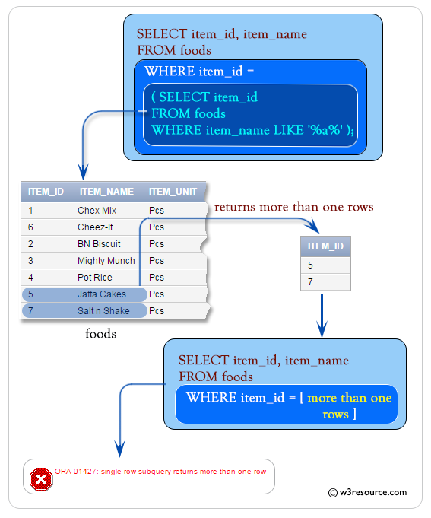
See our Model Database

Multiple Row Subqueries
Multiple row subquery returns one or more rows to the outer SQL statement. You may use the IN, ANY, or ALL operator in outer query to handle a subquery that returns multiple rows.
Contents:
- Using IN operator with a Multiple Row Subquery
- Using NOT IN operator with a Multiple Row Subquery
- Using ANY with a Multiple Row Subquery
- Multiple Column Subqueries
- SQL subqueries using DISTINCT

SQL: Using IN operator with a Multiple Row Subquery
IN operator is used to checking a value within a set of values. The list of values may come from the results returned by a subquery. See the following example :
To get 'ord_num', 'ord_amount', 'ord_date', 'cust_code' and 'agent_code' from the table 'orders' with following conditions :
Sample table : agents

Sample table : orders

in the outer query :
'agent_code' of 'orders' table must be in the list within IN operator in inner query :
in inner query :
'working_area' of 'agents' table must be 'Bangalore',
Here is the complete SQL statement:
SELECT ord_num,ord_amount,ord_date,
cust_code, agent_code
FROM orders
WHERE agent_code IN(
SELECT agent_code FROM agents
WHERE working_area='Bangalore');
Copy
Output :
ORD_NUM ORD_AMOUNT ORD_DATE CUST_CODE AGENT_CODE
---------- ---------- --------- ---------- ----------
200130 2500 30-JUL-08 C00025 A011
200105 2500 18-JUL-08 C00025 A011
200117 800 20-OCT-08 C00014 A001
200124 500 20-JUN-08 C00017 A007
200112 2000 30-MAY-08 C00016 A007
Let's break the above query and analyze what's going on in inner query. Here is the code of inner query :
SELECT agent_code FROM agents
WHERE working_area='Bangalore';
Copy
Output :
AGENT_CODE
----------
A001
A007
A011
The above query returns two agent codes 'A011' and 'A001'.
Pictorial Presentation :
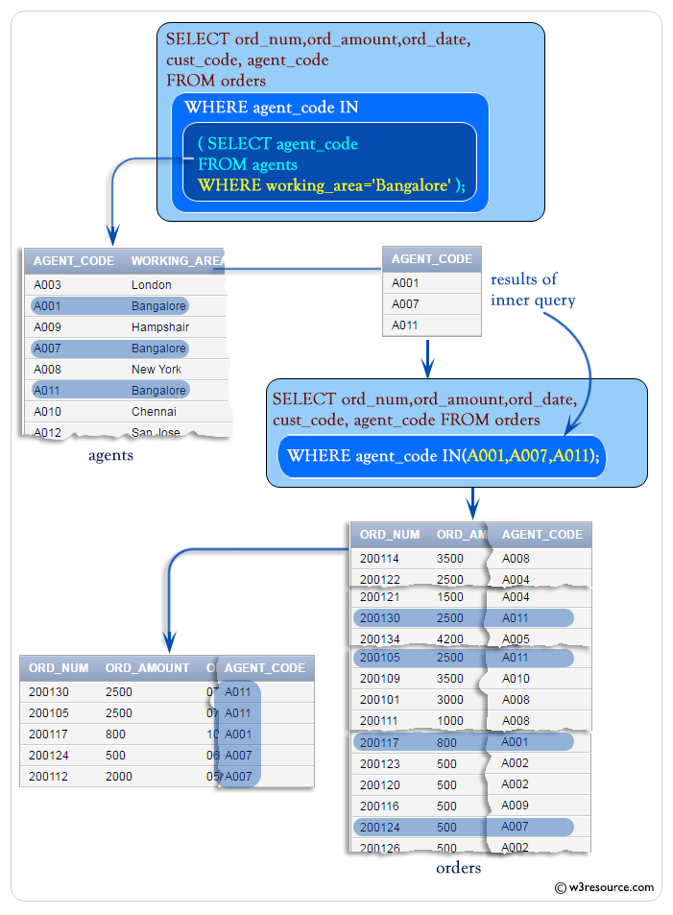

SQL: Using NOT IN operator with a Multiple Row Subquery
You can also use NOT IN operator to perform the logical opposite of IN operator. See the following example :
Sample table : orders

Sample table : agents

To get 'ord_num', 'ord_amount', 'ord_date', 'cust_code' and 'agent_code' from the table 'orders' with following conditions :
in outer query :
'agent_code' of 'orders' table must be other than the list within IN operator.
in inner query :
'working_area' of 'agents' table must be 'Mumbai'
Here is the complete SQL statement :
SELECT ord_num,ord_amount,ord_date,
cust_code, agent_code
FROM orders
WHERE agent_code NOT IN(
SELECT agent_code FROM agents
WHERE working_area='Bangalore');
Copy
Output:
ORD_NUM ORD_AMOUNT ORD_DATE CUST_CODE AGENT_CO
--------- ---------- --------- ---------- --------
200129 2500 20-JUL-08 C00024 A006
200118 500 20-JUL-08 C00023 A006
200111 1000 10-JUL-08 C00020 A008
200101 3000 15-JUL-08 C00001 A008
200114 3500 15-AUG-08 C00002 A008
200100 1000 08-JAN-08 C00015 A003
200127 2500 20-JUL-08 C00015 A003
200113 4000 10-JUN-08 C00022 A002
200133 1200 29-JUN-08 C00009 A002
200128 3500 20-JUL-08 C00009 A002
200126 500 24-JUN-08 C00022 A002
200120 500 20-JUL-08 C00009 A002
200123 500 16-SEP-08 C00022 A002
200106 2500 20-APR-08 C00005 A002
200116 500 13-JUL-08 C00010 A009
200132 4000 15-AUG-08 C00013 A013
200115 2000 08-FEB-08 C00013 A013
200125 2000 10-OCT-08 C00018 A005
200103 1500 15-MAY-08 C00021 A005
200134 4200 25-SEP-08 C00004 A005
.........
.........
Let's break the above query and analyze what's going on in inner query. Here is the code of inner query :
SELECT agent_code FROM agents
WHERE working_area='Bangalore';
Output :
AGENT_CODE
----------
A001
A007
A011
Pictorial Presentation :
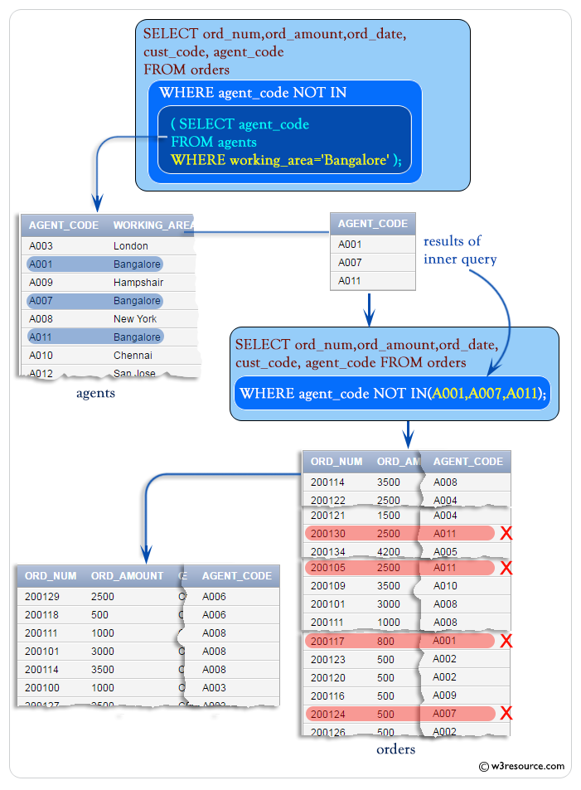

SQL: Using ANY with a Multiple Row Subquery
You can use the ANY operator to compare a value with any value in a list. You must place an =, <>, >, <, <= or >= operator before ANY in your query. The following example uses ANY to check if any of the agent who belongs to the country 'UK'.
Sample table : agents

Sample table : customer

To get 'agent_code', 'agent_name', 'working_area', 'commission' from 'agents' table with following conditions -
in outer query :
'agent_code' should be any 'agent_code' from 'customer' table
in inner query :
) 'cust_country' in the 'customer' table must be 'UK',
Here is the complete SQL statement :
SELECT agent_code,agent_name,working_area,commission
FROM agents
WHERE agent_code=ANY(
SELECT agent_code FROM customer
WHERE cust_country='UK');
Copy
Output:
AGENT_CODE AGENT_NAME WORKING_AREA COMMISSION
---------- ---------------------------------------- ----------------------------------- ----------
A009 Benjamin Hampshair .11
A003 Alex London .13
A006 McDen London .15
Pictorical Presentation :
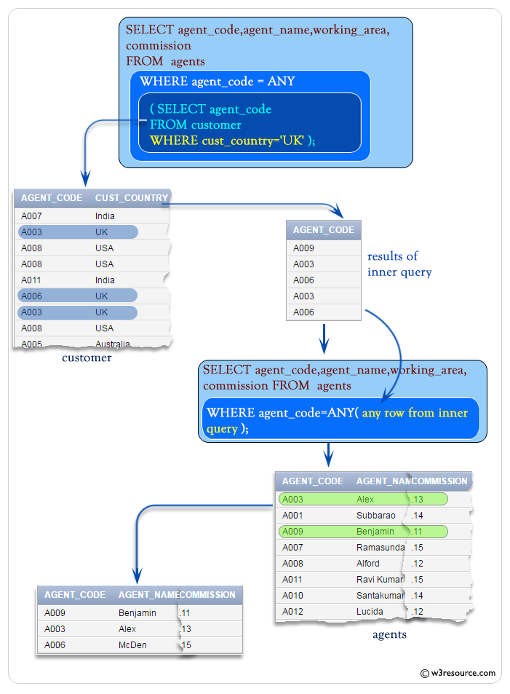

SQL: Multiple Column Subqueries
You can write subqueries that return multiple columns. The following example retrieves the order amount with the lowest price, group by agent code.
Sample table : orders

select ord_num, agent_code, ord_date, ord_amount
from orders
where(agent_code, ord_amount) IN
(SELECT agent_code, MIN(ord_amount)
FROM orders
GROUP BY agent_code);
Copy
Output:
ORD_NUM AGENT_CODE ORD_DATE ORD_AMOUNT
---------- ---------- --------- ----------
200104 A004 13-MAR-08 1500
200121 A004 23-SEP-08 1500
200126 A002 24-JUN-08 500
200120 A002 20-JUL-08 500
200123 A002 16-SEP-08 500
200124 A007 20-JUN-08 500
200116 A009 13-JUL-08 500
200105 A011 18-JUL-08 2500
200130 A011 30-JUL-08 2500
200131 A012 26-AUG-08 900
200135 A010 16-SEP-08 2000
200115 A013 08-FEB-08 2000
200117 A001 20-OCT-08 800
200111 A008 10-JUL-08 1000
200118 A006 20-JUL-08 500
200103 A005 15-MAY-08 1500
200100 A003 08-JAN-08 1000
Pictorial Presentation :
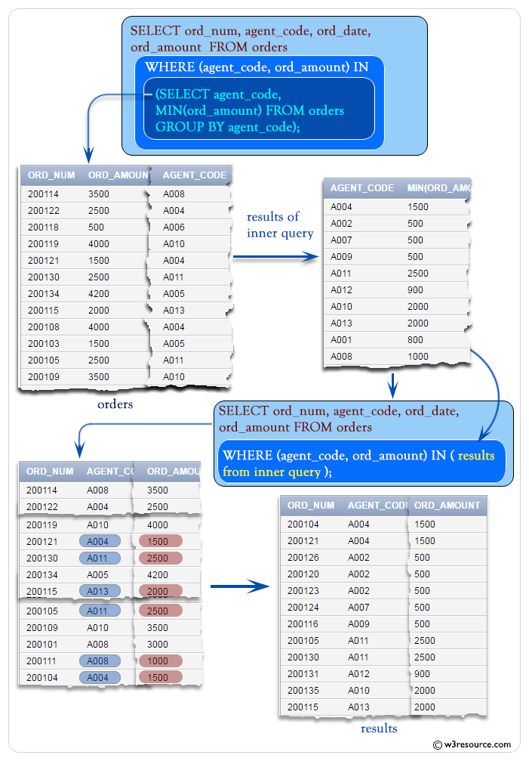

SQL: Subqueries using DISTINCT
In this section, we are discussing the usage of DISTINCT clause in a subquery.
Example :
Sample table : orders

To get 'ord_num', 'ord_amount', 'ord_date', 'cust_code' and 'agent_code' from the table 'orders' with following conditions -
in outer query :
the 'agent_code' of 'orders' table must be the same 'agent_code' of 'orders' table with following conditions -
'agent_code' of 'orders' table should come distinctly with following
inner query :
;the 'cust_code' of 'orders' table must be 'C00005'
Here is the complete SQL statement :
SELECT ord_num,ord_amount,ord_date,
cust_code, agent_code
FROM orders
WHERE agent_code=(
SELECT DISTINCT agent_code
FROM orders WHERE cust_code='C00005');
Copy
Output :
ORD_NUM ORD_AMOUNT ORD_DATE CUST_CODE AGENT_CODE
---------- ---------- --------- ---------- ----------
200106 2500 20-APR-08 C00005 A002
200123 500 16-SEP-08 C00022 A002
200120 500 20-JUL-08 C00009 A002
200126 500 24-JUN-08 C00022 A002
200128 3500 20-JUL-08 C00009 A002
200133 1200 29-JUN-08 C00009 A002
200113 4000 10-JUN-08 C00022 A002
The inner of the above query returns the 'agent_code' A002.
The simplified form of above code is :
SELECT ord_num,ord_amount,ord_date,
cust_code, agent_code
FROM orders
WHERE agent_code='A002';
Copy
Pictorial Presentation :
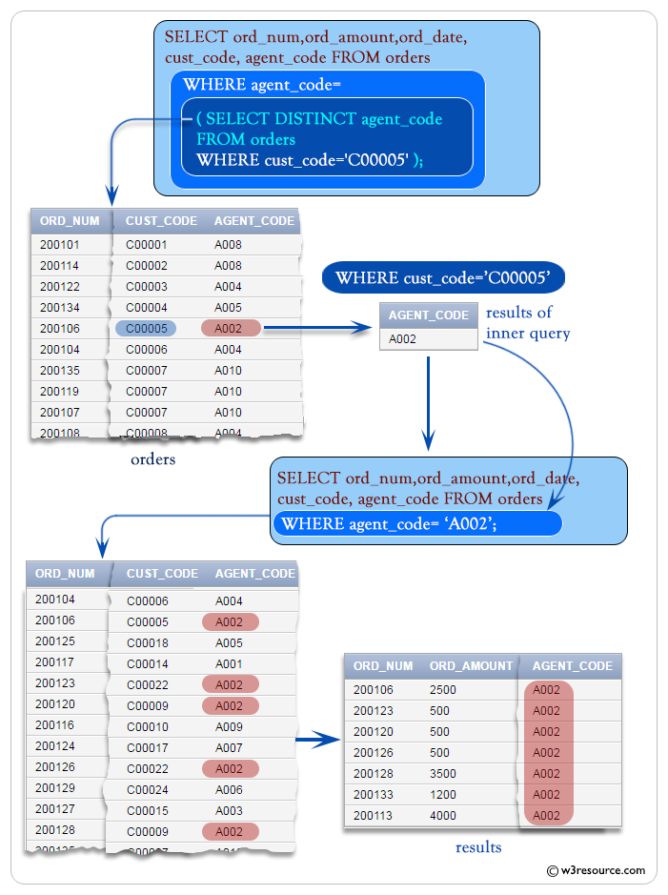
Practice SQL Exercises

